**[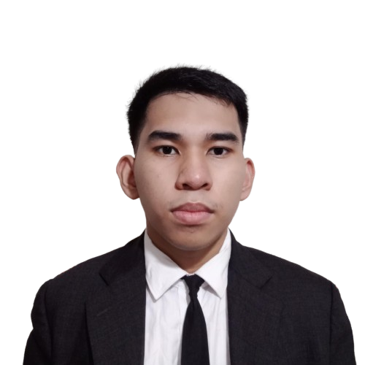](https://adornadowilliam2.github.io/resume/)NAME: Adornado, William B Jr.**

Address: 393, Rayos Compound, Rosario Pasig City

E-mail: adornadowilliam@gmail.com

Contact No.: 09814363602

**OBJECTIVE:**

Looking for a suitable On-the-Job Training where I could enhance my skills and develop my career growth.

**SKILLS:**

* Knowledgeable in other programming language like JavaScript, PHP, Java, Python, Kotlin and Visual Basic.
* Knowledgeable in C.R.U.D (Create, Retrieve, Update and Delete), Databases and Api (Application Programming Interface).
* Knowledgeable in web framework and library like Laravel, React and React-Native.
* Know how to configure Windows Server connect to the Windows Client.
* Knowledgeable in Networking.
* Know how to use git and git commands.
* Knowledgeable about DevOps like Docker.
* Know how to make an application using Android Studio and React-Native.
* Background in making a Booking Management System

**EDUCATIONAL ATTAINMENT:**

**Tertiary MFI Polytechnic Institute Inc. (formerly Meralco Foundation Inc.)**

Pasig City

Information Technology

School Year: 2024-Present

**Secondary** **Eusebio High School**

Pasig City

School Year 2016-2023

**CERTIFICATE:**

* **IT Essentials Signed E-Certificate from Cisco,** MFI Polytechnic Institute Inc. (formerly Meralco Foundation Inc.), Pasig City

**AWARDS:**

* **3RD Place in Web Skill Competition,** MFI Polytechnic Institute Inc. (formerly Meralco Foundation Inc.), Pasig City

**PERSONAL INFORMATION:**

**Birth Date** : May 6, 2005

**Civil Status** : Single

**Age** : 19

**Birth Place** : Pasig City